FINDING THE NEXT TERMS

Write down the next two terms of the sequence: 5; 12; 23; 38; …

STEP 1: Find the first differences between the terms
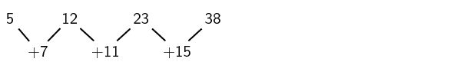

STEP 2: Find the second differences between the terms
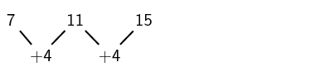
So there is a common second difference of 44. We can therefore conclude that this is a quadratic sequence.
Continuing the sequence, the next first differences will be:
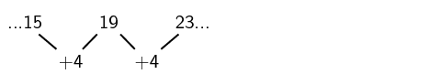Add the second difference to
the first difference.
Hence, the next two terms of the sequence will be:
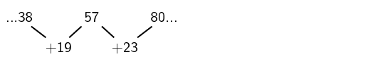Then extent the sequence
by adding the NEW first
differences consecutively
So the sequence will be: 5;12 ; 23; 38; 57; 80; …
EXERCISE
In each of the following patterns, write down the next two terms:
- 4; 10; 20; 34; ..
- 0; 9; 24; 45; ..

